SOFTWARE ENGINEERING LAST ASSIGNMENT
COURSE: SOFTWARE ENGINEERING
LECTURER: Dr GASHEMA Gaspard
GROUP: H
SUB GROUP: 1
QUESTION: 1

GROUP MEMBERS:

1. Joseph MUTANGANA 29061
2. Gihozo Gisline 28775
3. Araje Divin 26461
4. Ishimwe Gad 29062
5. Ituze Paradis 26147
6. Keza NTIRIVAMUNDA Belyse 28953
7. CYIZA Olivier 28237
8. Isaro Roxane 28762
9. Uwajeneza Melissa 28779
10. ISHIMWE TETA KEYLA 29390
11. UMWIZERWA Ruth 28235
12. Rebeka Patience 26277

1. Use-Case Diagram showing all actors and major use cases
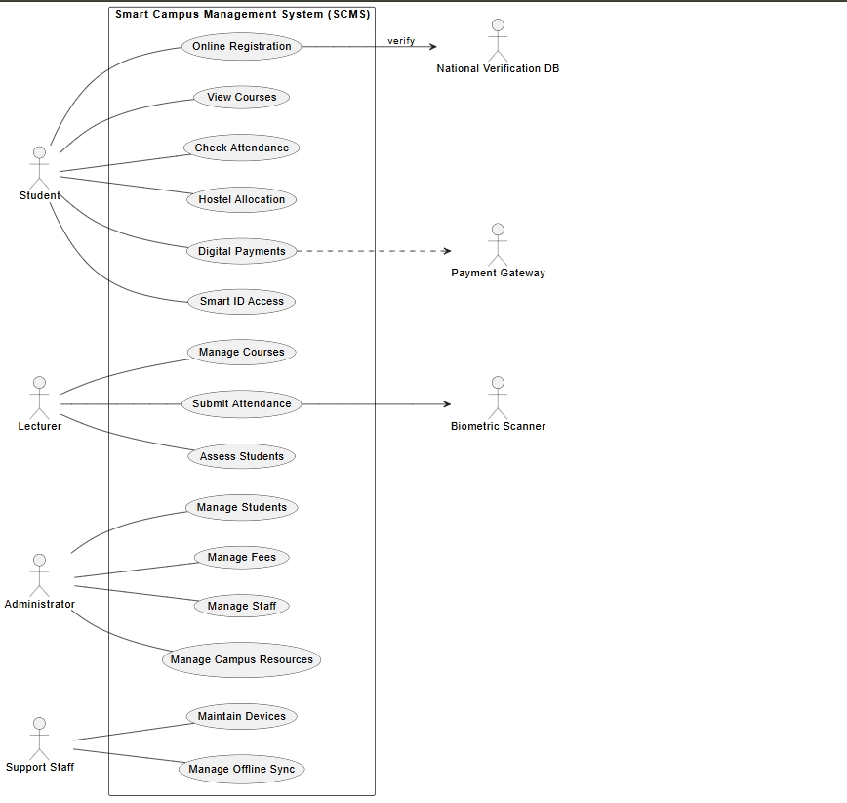
2. Class Diagram with attributes, methods, and relationships
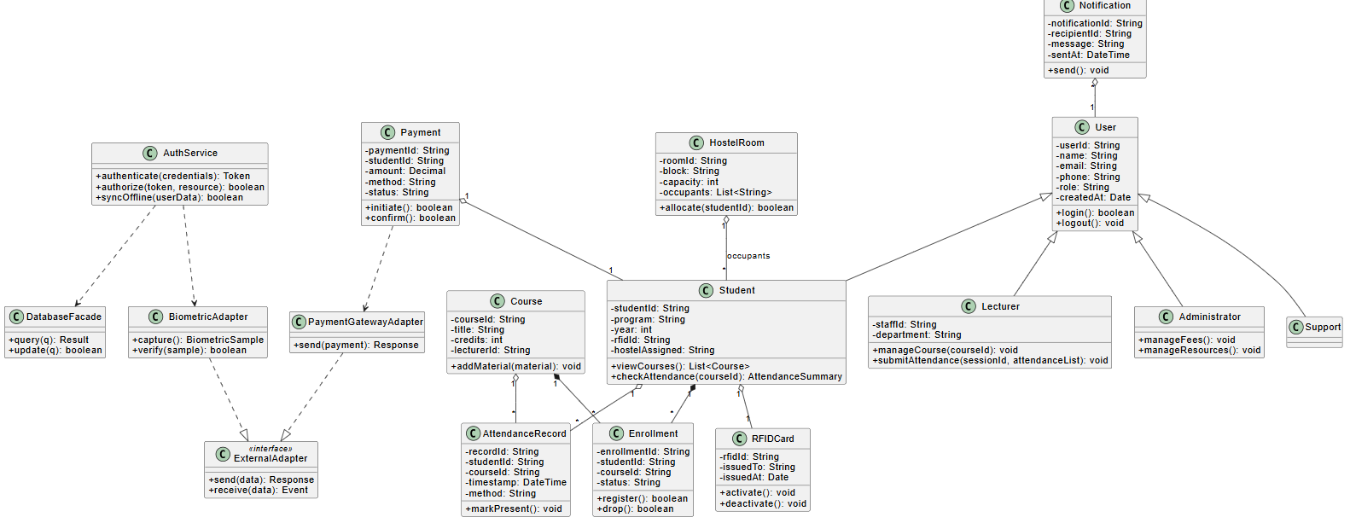
3. Sequence Diagram for “Student Course Registration” and “Biometric Attendance”

a) Sequence for Student Registration
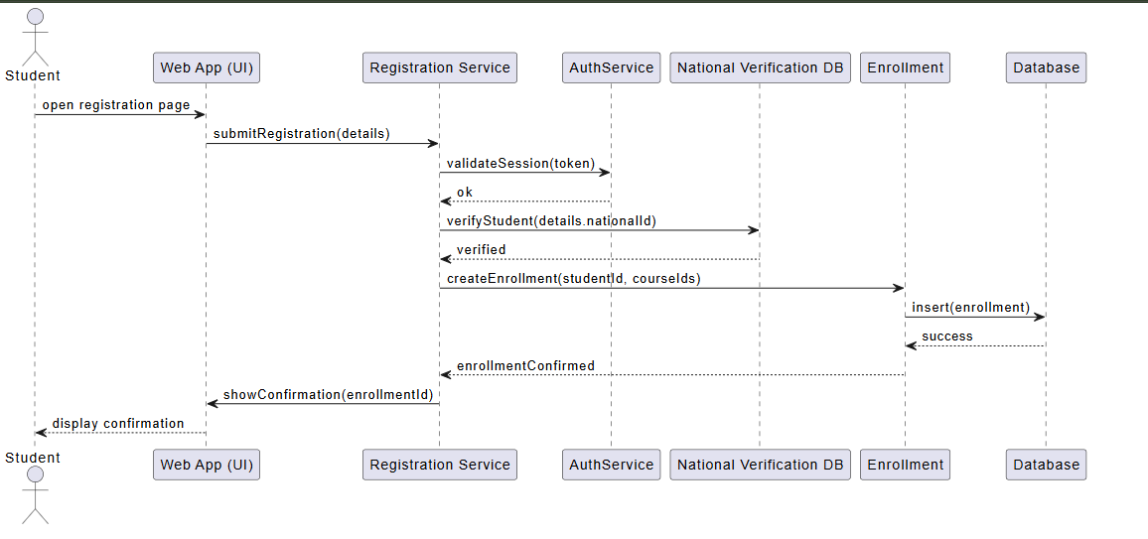
b) Sequence for Biometric Attendance
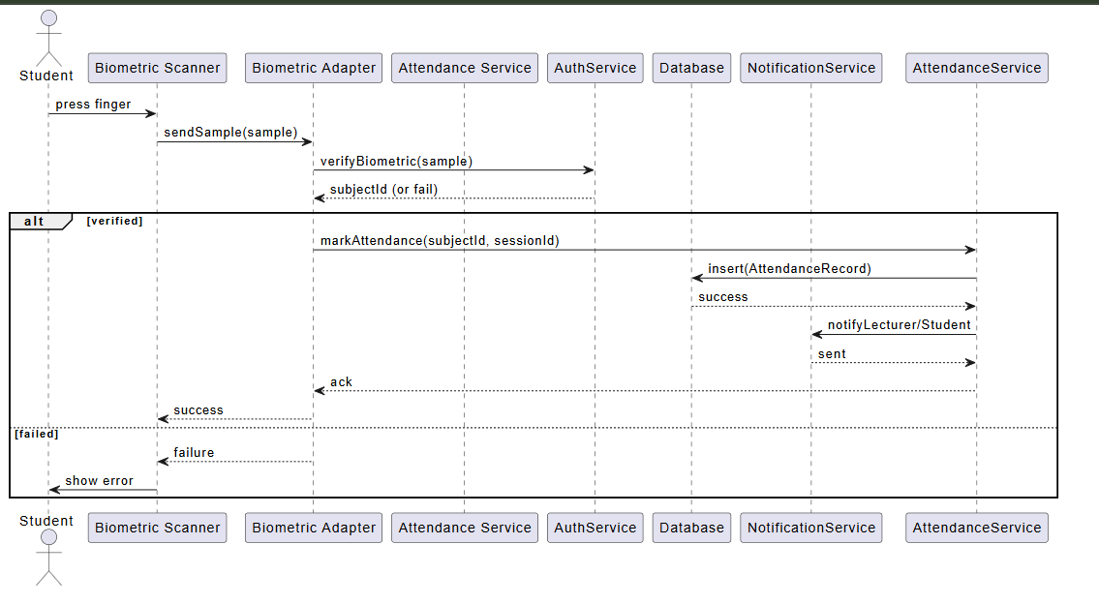

4. Activity Diagram for the “Hostel Allocation Process”
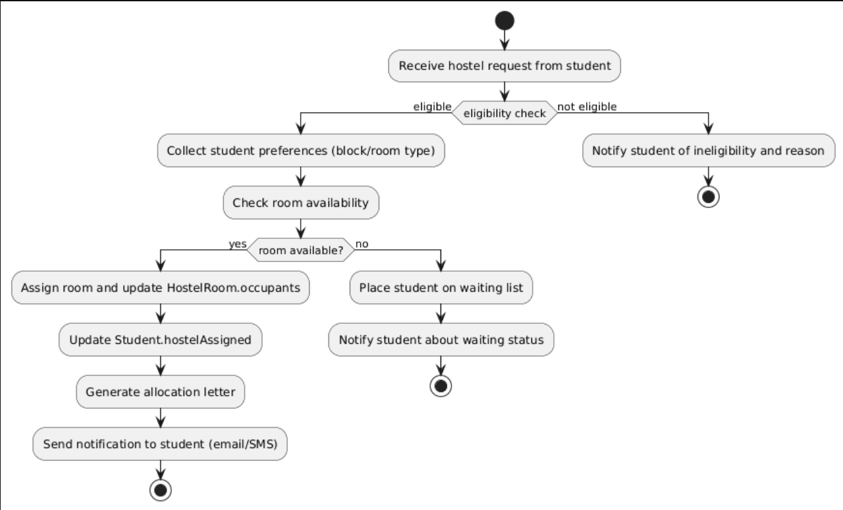

5. Deployment Diagram showing servers, databases, and external systems
